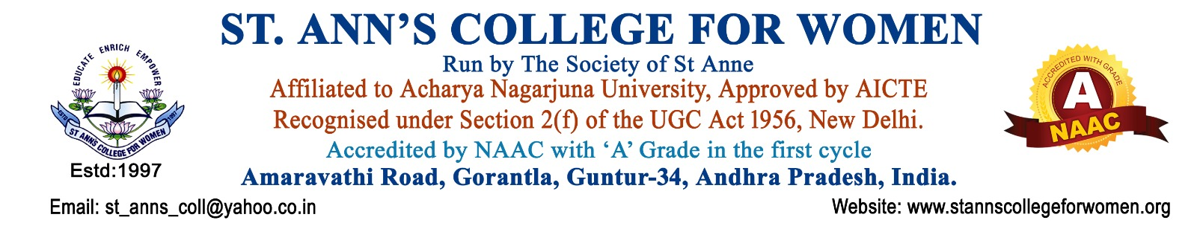

Library Committee
Guidelines & Procedures
1. Introduction
The Library Committee of St. Ann’s College for Women, Gorantla, Guntur is constituted to ensure effective planning, development, management, and utilization of library resources and services for academic excellence and research support.
The committee functions in alignment with NAAC quality indicators to promote reading habits, digital learning, research culture, and efficient library management practices. The committee supports students and faculty by providing access to quality learning resources, journals, e-resources, and digital library facilities.
2. Objectives
The objectives of the Library Committee are to:
- Plan and oversee the development of library resources and services.
- Recommend purchase of books, journals, magazines, e-resources, and study materials.
- Promote effective utilization of library facilities and digital resources.
- Support academic, research, and learning requirements of students and faculty.
- Create awareness regarding digital library services and e-learning resources.
- Maintain discipline and proper functioning of the library.
- Encourage reading habits and independent learning among students.
- Conduct orientation programs on library usage and information literacy.
- Ensure proper maintenance of records and library resources.
3. Scope of Activities
The Library Committee shall oversee:
- Library management and administration
- Book selection and procurement
- Subscription of journals and e-resources
- Digital library services
- Reading room management
- Library orientation programs
- User services and circulation system
- Research and reference support
- Maintenance of records and stock verification
4. Constitution of the Committee
The Library Committee shall consist of:
- Principal – Chairperson
- Librarian – Coordinator
- Senior Faculty Members
- IQAC Representative
- Department Representatives
- Student Representatives
- Administrative Representative (if required)
The composition of the committee may be revised by the Principal as per institutional requirements.
5. Roles and Responsibilities
The committee shall:
- Plan and monitor the development of library facilities and services.
- Recommend purchase of books, journals, periodicals, newspapers, and e-resources.
- Ensure implementation of library rules, regulations, and discipline.
- Promote usage of digital library resources, N-LIST, DELNET, and e-learning platforms.
- Conduct orientation and awareness programs for students and faculty.
- Monitor issue and return systems for smooth functioning.
- Ensure proper cataloguing, classification, and maintenance of library resources.
- Support teaching, learning, research, and extension activities.
- Conduct stock verification and library audits periodically.
- Maintain records and reports of library activities and usage statistics.
6. Library Procedures
Step 1: Requirement Collection
- Departments and faculty members shall submit requirements for:
  - Books
  - Journals
  - Reference materials
  - E-resources
  - Competitive examination materials
Step 2: Review and Recommendation
- The Library Committee shall review the requirements and recommend suitable resources for purchase.
Step 3: Procurement Process
- Approved books and resources shall be purchased following institutional procedures and budget availability.
Step 4: Accession and Cataloguing
- Newly procured books shall be:
  - Entered in accession registers
  - Catalogued and classified properly
  - Arranged systematically for easy access
Step 5: Circulation and User Services
- Books shall be issued and returned as per library rules.
- Digital resources and reference services shall be made accessible to users.
Step 6: Monitoring and Maintenance
- The committee shall monitor:
  - Book circulation
  - Reading room usage
  - Digital library access
  - Library discipline
  - Maintenance of resources
7. Library Rules and Regulations
The library users shall:
- Maintain silence and discipline inside the library.
- Handle books and resources carefully.
- Return borrowed books within the prescribed time.
- Avoid damage, marking, or misuse of library materials.
- Carry valid identity cards while using library facilities.
- Follow digital resource usage policies and ethical practices.
The library reserves the right to impose penalties for loss, damage, or delayed return of books.
8. Digital Library and E-Learning Services
The committee shall promote:
- Usage of e-books and e-journals
- N-LIST and digital database access
- Online learning platforms
- Open educational resources
- ICT-enabled learning and research support
Awareness programs and training sessions shall be conducted regularly to familiarize users with digital services.
9. Orientation and User Education Programs
The Library Committee shall organize:
- Library orientation programs for newly admitted students
- Information literacy programs
- Reading promotion activities
- Book exhibitions and review sessions
- Workshops on digital resource usage and referencing methods
10. Support for Academic and Research Activities
The library shall support:
- Curriculum-related learning resources
- Research and project work
- Competitive examination preparation
- Faculty publications and research activities
- Access to reference and scholarly materials
11. Meetings
- The Library Committee shall conduct periodic meetings to review library functioning and development activities.
- Minutes of meetings and Action Taken Reports shall be maintained properly.
12. Documentation and Records
The following records shall be maintained:
- Accession Registers
- Stock Registers
- Issue and Return Registers
- Digital Resource Usage Records
- Membership Records
- Visitor Registers
- Committee Meeting Minutes
- Book Purchase Records
- Stock Verification Reports
- Library Activity Reports
- Annual Reports and Usage Statistics
13. NAAC Compliance
The Library Committee functions in alignment with:
- NAAC Quality Indicators
- Library and Learning Resource Standards
- ICT-enabled Teaching-Learning Practices
- Student-Centric Learning Framework
The committee contributes to:
- Quality Learning Resources
- Research Support
- Digital Learning
- Academic Excellence
- Information Literacy
- Institutional Quality Enhancement
14. Expected Outcomes
The activities of the Library Committee are expected to:
- Improve access to quality academic and research resources.
- Promote reading habits and self-learning culture.
- Enhance digital literacy and information access.
- Strengthen research and academic support services.
- Ensure efficient and transparent library management.
- Support holistic academic development of students and faculty.

15. Conclusion
St. Ann’s College for Women, Gorantla, Guntur is committed to providing quality library and information services that support academic excellence, research, innovation, and lifelong learning. The Library Committee plays a vital role in strengthening learning resources, promoting knowledge acquisition, and enhancing the educational environment in alignment with NAAC quality standards.

